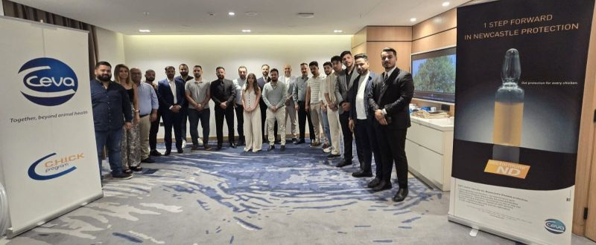

CEVA SANTE ANIMALE and #NakhletErbil were proud to host today at Vocco Hotel Beirut a seminar on Vaccination Techniques in Poultry Hatcheries, dedicated to the Iraqi poultry sector.
With 20 top poultry producers and dealers from Iraq in attendance, this event was an opportunity to exchange know-how, best practices, and innovations in poultry health
ENG. Abdallah Cherfane (EMBA) , Cluster Manager (Near East, Gulf & Sudan), 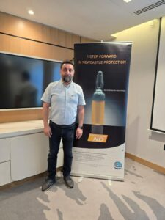
Abdallah, opened the day by welcoming the distinguished guests and emphasizing how precise vaccination techniques contribute significantly to a healthy and productive poultry cycle.

ENG. Safaa Alam, Poultry Veterinary Services Manager


Safaa, led an in-depth technical session showcasing CEVA’s advanced poultry vaccine range — explaining their strategic use per virus and disease, backed by regional and international trials.

ENG. Hanna Zailaa, Vaccination Specialist
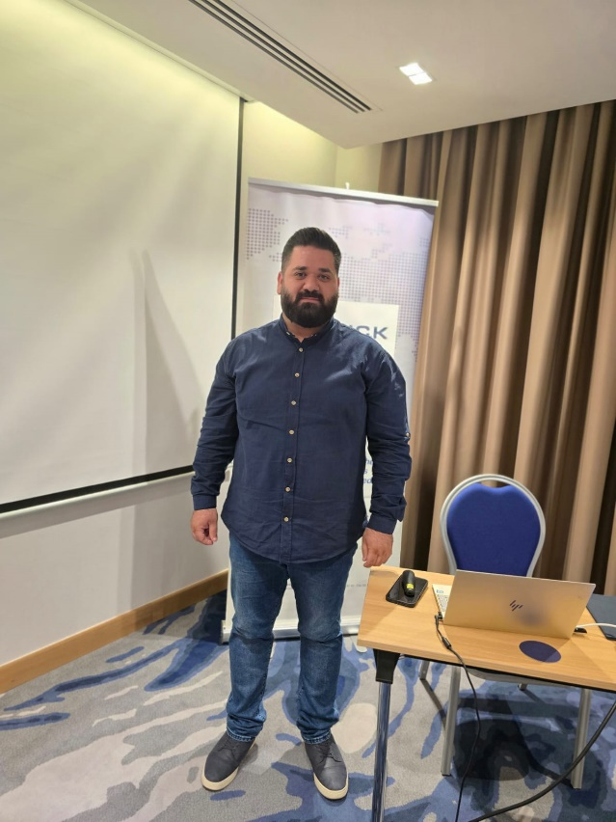
Hanna, shared critical insights on vaccine handling & preparation, underlining the importance of proper temperature management – reminding us that both heat and cold can compromise vaccine efficacy.

An engaging Q&A session, led by Eng. Abdallah and Eng. Safaa, provided valuable clarity for the participants
— addressing key concerns in their management practices and offering practical solutions to their ongoing challenges.

