**Middle East Poultry Expo 2025**,

Ceva team was privileged to take part in the **Middle East Poultry Expo 2025**, hosted in **Saudi Arabia**—a regional leader in poultry production and a key hub for agricultural innovation across the Middle East and Africa.  
  
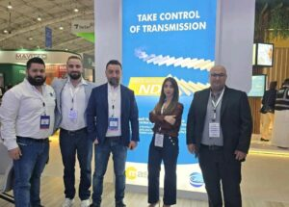

Hanna Zailaa.Carlos Al Dib,Abdallah Cherfane,Safaa Alam,Elias Zgheib  
  
 The 2025 edition gathered **over 320 exhibitors from 40 countries** and welcomed  
**more than 11,000 visitors representing 54 nations**,  
underscoring its position as one of the most significant and globally diverse events in the poultry industry.

 Organized under the patronage of the **Ministry of Environment, Water and Agriculture**, the exhibition served as a high-impact platform to promote investment opportunities, stimulate innovation, and enhance international collaboration across the poultry value chain.

**For Ceva**, the event represented a valuable opportunity to strengthen partnerships with local stakeholders, suppliers, and international experts—advancing our shared mission to **improve poultry health**, optimize productivity, and contribute to a sustainable and secure food future.

 We express our heartfelt appreciation to all **participants and partners** who contributed to the success of this prestigious event. A special acknowledgment goes to our esteemed local distributor,  
  
**MAS**, for their continuous dedication and collaboration.  
