WVPA MALAYSIA 2025

CEVA at the WVPA 2025 – Near East & Gulf:
Strengthening Partnerships and Advancing Poultry Health
We are pleased to share key moments from CEVA’s participation in the World Veterinary Poultry Association (WVPA) 2025 Congress in the Near East & Gulf region, including the memorable gala dinner where we had the opportunity to connect with our valued customers and partners.
CEVA’s Near East & Gulf teams played a leading role throughout the event, particularly during the CEVA Symposium: “Integrated Vaccination Solutions for Superior Disease Control.” Our participation underscored CEVA’s ongoing commitment to scientific collaboration and innovation in poultry health, reinforcing our position as a trusted partner across the region.
We were honored to welcome customers from various countries across the Near East and Gulf, engaging in valuable discussions on market trends, emerging challenges, and shared opportunities for growth.
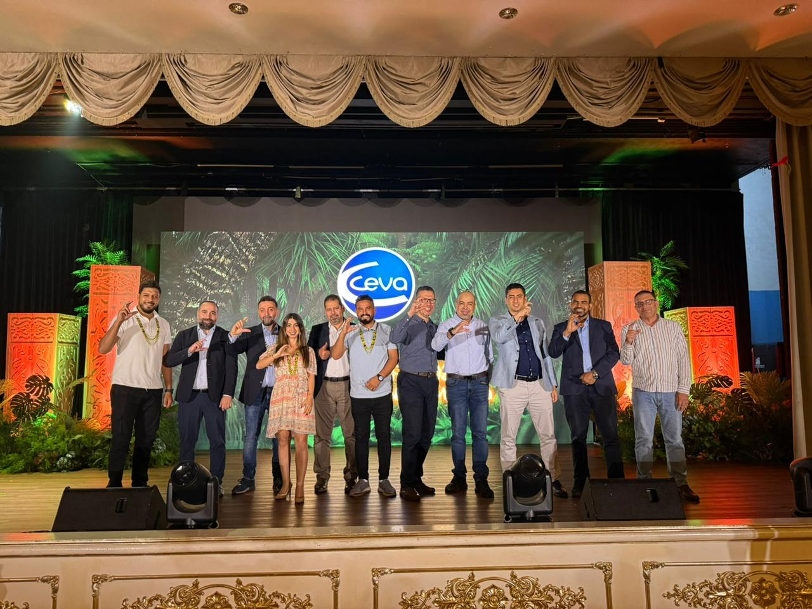
We extend our sincere appreciation to all CEVA colleagues, distinguished speakers, and customers who contributed to the success of this event. Your collaboration, insights, and continued trust inspire us to further advance sustainable solutions for poultry health and productivity.

